LSTM vs Transformer Encoder for AG News Classification

1. Introduction
This project compares two neural text classifiers trained from scratch on the AG News four-class classification task: a bidirectional LSTM classifier and a Transformer Encoder classifier. The goal is not simply to maximize accuracy. The project evaluates how recurrent sequence modeling and self-attention differ in classification performance, training behavior, convergence patterns, data efficiency, and failure cases.
Both models use the same dataset source, split procedure, tokenizer, vocabulary, maximum sequence length, optimizer family, training budget, and evaluation metrics. This controlled setup makes the comparison more informative than a raw leaderboard-style accuracy result. The main research question is: under a shared preprocessing and training pipeline, how do the LSTM and Transformer Encoder differ on AG News classification?

2. Dataset And Preprocessing
The project uses Hugging Face `fancyzhx/ag_news` as the only dataset source. The official training split was divided into 108,000 training examples and 12,000 validation examples using `train_test_split(test_size=0.1, seed=42)`. The official test split contains 7,600 examples and was reserved for final evaluation only.
The four labels are `World`, `Sports`, `Business`, and `Sci/Tech`. The official test split is balanced, with 1,900 examples per class. The training split is also nearly balanced: 26,991 World, 26,966 Sports, 27,100 Business, and 26,943 Sci/Tech examples. Labels were verified as integer class indices `0, 1, 2, 3`, which matches the requirement for `torch.nn.CrossEntropyLoss`.
Texts were tokenized with a reproducible regular-expression tokenizer. The vocabulary was built only from the training split to avoid vocabulary leakage. The vocabulary size was capped at 20,000 tokens, with reserved indices for padding and unknown tokens. The main comparison used a maximum sequence length of 128 tokens. Both models received the same padded and truncated token IDs, and padding masks were used during LSTM pooling and Transformer attention.

3. Models
The LSTM uses an embedding layer, one-layer bidirectional LSTM, masked mean pooling, dropout, and a linear classifier. The Transformer Encoder uses embeddings, learned positional embeddings, two encoder layers, four heads, masked mean pooling, dropout, and a classifier.
Model | Trainable parameters
LSTM | 2,825,220
Transformer Encoder | 2,973,444

Setting | LSTM | Transformer Encoder
Vocabulary size | 20,000 | 20,000
Embedding dimension | 128 | 128
Encoder depth | 1 bidirectional LSTM layer | 2 Transformer Encoder layers
Hidden / feedforward | 128 per direction | 512 feedforward
Attention heads | Not applicable | 4
Pooling | Masked mean pooling | Masked mean pooling
Dropout | 0.2 | 0.2
Optimizer / LR | Adam / 1e-3 | Adam / 1e-3
Epochs / batch | 6 / 64 | 6 / 64

Both models were trained from scratch with no pretrained embeddings or pretrained language models.

4. Experiments
The main comparison trained both models for 6 epochs using Adam, learning rate `1e-3`, batch size 64, dropout 0.2, seed 42, and CPU execution. The evaluation metrics were accuracy and macro F1-score. Macro F1 was included because AG News has multiple classes and the assignment requires class-sensitive evaluation, even though the dataset is nearly balanced.
The required ablation changed one major factor: the fraction of training data. The tested fractions were 25%, 50%, and 100% of the training split. The hypothesis was that the LSTM would be more stable with less data, while the Transformer Encoder would benefit more from the full dataset because self-attention has greater capacity.
An optional extension compared maximum sequence lengths of 128 and 256 tokens. This tested whether longer context improved validation performance enough to justify the additional training cost.

5. Results
Model | Split | Loss | Accuracy | Macro F1
LSTM | valid | 0.3402 | 0.9113 | 0.9108
Transformer Encoder | valid | 0.3103 | 0.9118 | 0.9115
LSTM | test | 0.3459 | 0.9120 | 0.9118
Transformer Encoder | test | 0.3066 | 0.9125 | 0.9126

Both models reached similar final performance. The Transformer Encoder was slightly better on final test metrics, but the gap was small.
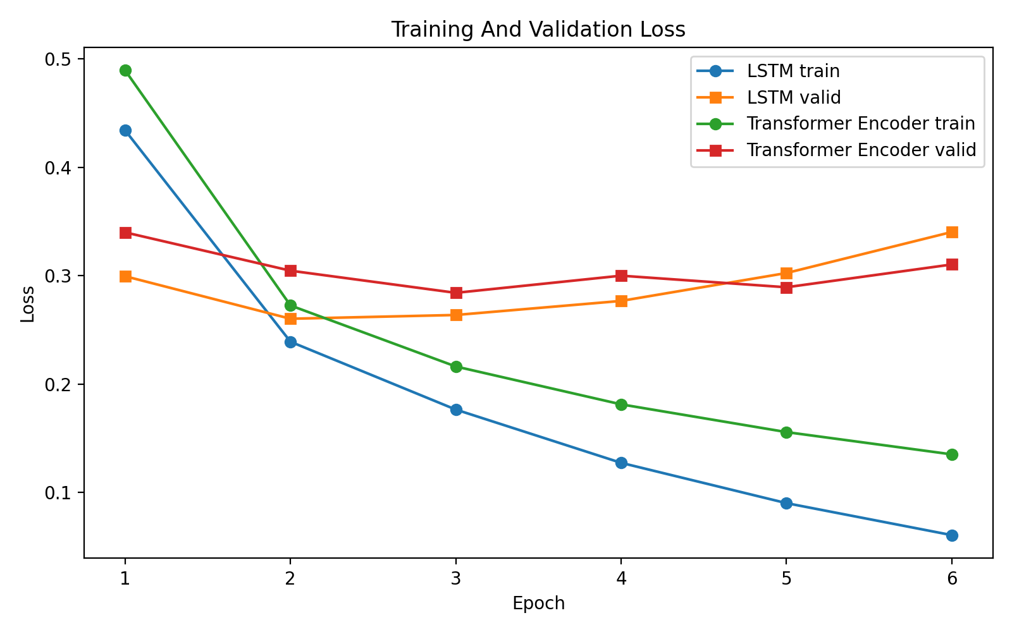
Figure 1. Training and validation loss curves.
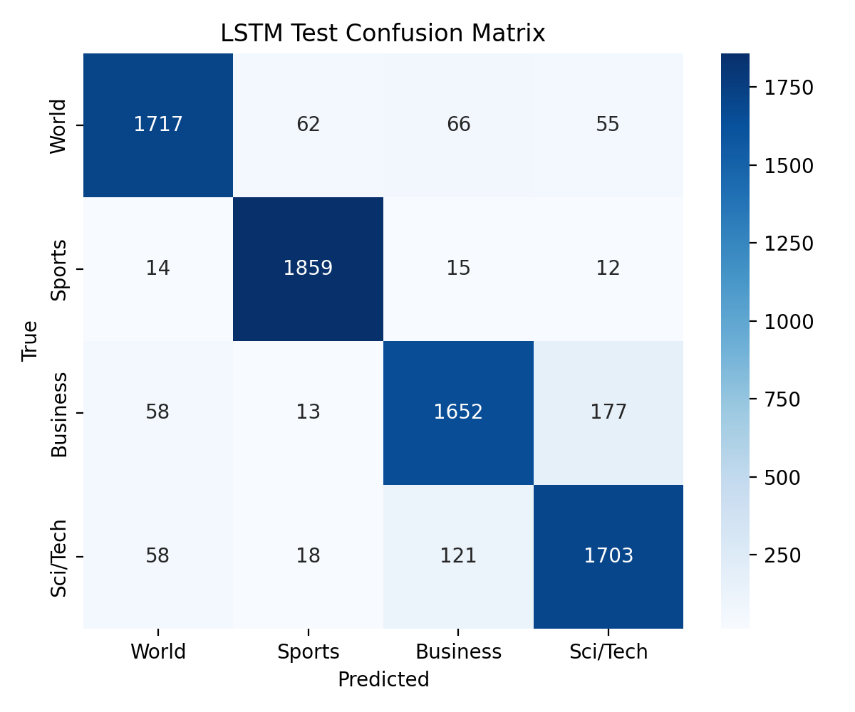
Figure 2. LSTM final test confusion matrix.
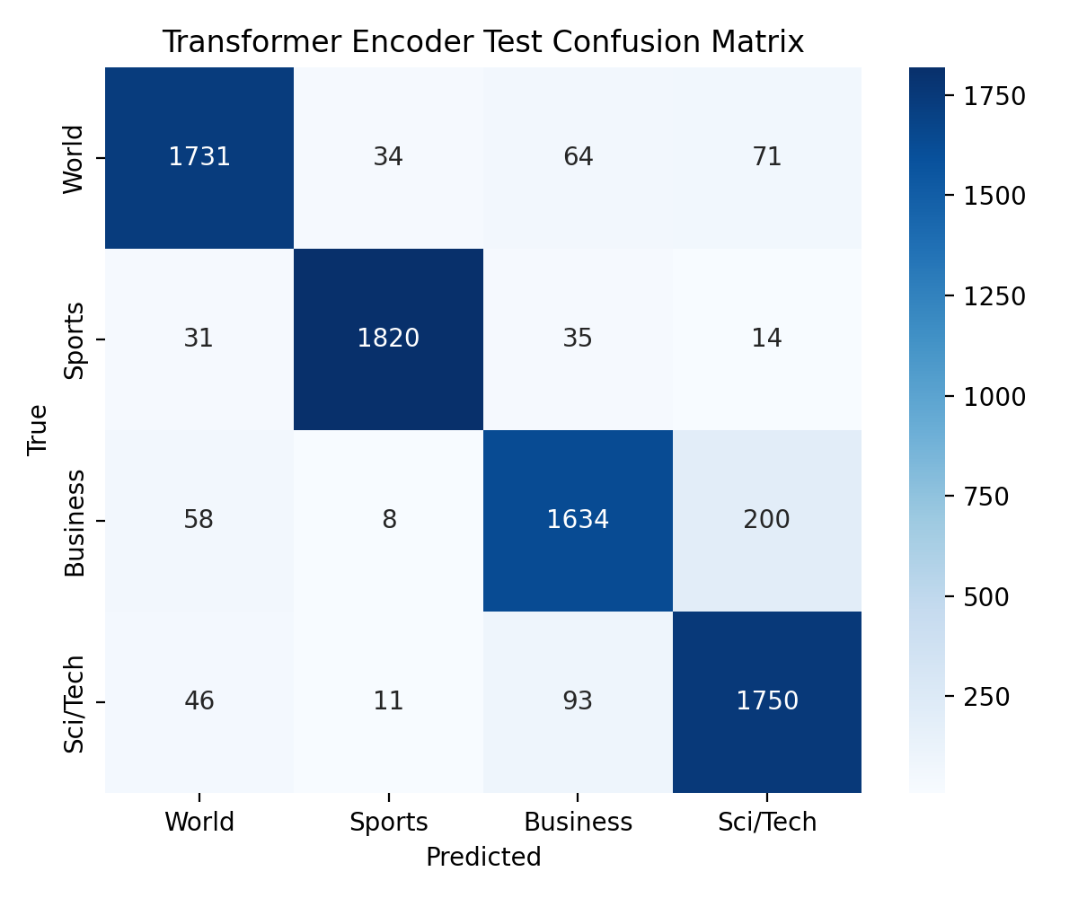
Figure 3. Transformer Encoder final test confusion matrix.
Both models overfit by epoch 6. Sports was easiest for both models, and Business/Sci/Tech confusion was the main class-level error pattern.

6. Ablation Study
Hypothesis: LSTM is more stable with limited data, while Transformer Encoder benefits more from full data. The changed variable was training-set fraction; all other major settings were controlled.
Model | Train fraction | Accuracy | Macro F1
LSTM | 25% | 0.8719 | 0.8713
Transformer Encoder | 25% | 0.8699 | 0.8696
LSTM | 50% | 0.8944 | 0.8940
Transformer Encoder | 50% | 0.8901 | 0.8895
LSTM | 100% | 0.9089 | 0.9082
Transformer Encoder | 100% | 0.9146 | 0.9142

The ablation supports the hypothesis: LSTM led at 25% and 50%, while Transformer Encoder led at 100%.
Model | Max length | Loss | Accuracy | Macro F1
LSTM | 128 | 0.3402 | 0.9113 | 0.9108
Transformer Encoder | 128 | 0.3103 | 0.9118 | 0.9115
LSTM | 256 | 0.3535 | 0.9065 | 0.9058
Transformer Encoder | 256 | 0.3304 | 0.9062 | 0.9059

The optional sequence-length extension showed that 256-token inputs reduced validation performance for both models.

7. Failure Analysis
The selected examples cover both-wrong, LSTM-only wrong, and Transformer-only wrong cases.
# | Input excerpt | True | LSTM | Transformer | LSTM c. | Trans. c. | Likely reason
1 | Live: Olympics day four Richard Faulds and Stephen Parry are going fo... | World | Sports | Sports | 0.94 | 1.00 | Sports terms dominate the short text even though the dataset section is World.
2 | Intel to delay product aimed for high-definition TVs SAN FRANCISCO --... | Business | Sci/Tech | Sci/Tech | 0.99 | 1.00 | A technology company story overlaps Business and Sci/Tech vocabulary.
3 | Prediction Unit Helps Forecast Wildfires (AP) AP - It's barely dawn w... | Sci/Tech | World | Sci/Tech | 0.48 | 0.98 | Weather prediction language mixes science terms with world-event framing.
4 | Some People Not Eligible to Get in on Google IPO Google has billed it... | Sci/Tech | Business | Sci/Tech | 0.82 | 0.83 | Finance and technology cues conflict; the IPO framing points toward Business.
5 | Teenage T. rex's monster growth Tyrannosaurus rex achieved its massiv... | Sci/Tech | Sci/Tech | Business | 0.44 | 0.56 | Very short science item gives limited context; the Transformer overweights business-like wording.
6 | IBM to hire even more new workers By the end of the year, the computi... | Sci/Tech | Sci/Tech | Business | 0.84 | 0.62 | Company hiring story overlaps labor/business cues and computing-company Sci/Tech label.

Most remaining errors are semantic boundary cases involving class overlap or misleading surface cues, not label-format or preprocessing failures.

8. Conclusion
Both from-scratch models performed well on AG News under the controlled setup, reaching about 91.2% final test accuracy. The Transformer Encoder achieved the best final test metrics, but only by a small margin. The LSTM was stronger in lower-data ablation settings, while the Transformer Encoder benefited more from the full training set.
The required dataset-size ablation supports the original data-efficiency hypothesis. The optional sequence-length ablation showed that simply increasing maximum sequence length from 128 to 256 did not improve validation metrics. The most reasonable next experiment would be to tune early stopping or regularization, because both models show overfitting by the final epoch.

